Brainstorm

& idea prioritization

#### Use this template in your own brainstorming sessions so your team can unleash their imagination and start shaping concepts even if you're not sitting in the same room.

**10 minutes** to prepare

**1 hour** to collaborate

**2-8 people** recommended

**Before you collaborate**

A little bit of preparation goes a long way with this session. Here’s what you need to do to get going.

**10 minutes**

1. **Team gathering**

Define who should participate in the session and send an invite. Share relevant information or pre-work ahead.

1. **Set the goal**

Think about the problem you'll be focusing on solving in the brainstorming session.

1. **Learn how to use the facilitation tools**

Use the Facilitation Superpowers to run a happy and productive session.

[**Open article**](https://support.mural.co/en/articles/2113740-facilitation-superpowers)

**1**

### Define your problem statement

What problem are you trying to solve? Frame your problem as a How Might We statement. This will be the focus of your brainstorm.

**5 minutes**

**PROBLEM**

Sometimes elderly people forget to take their medicine at the correct time.They also forget which medicine He / She should take at that particular time.

And it is difficult for doctors/ caretakers to monitor the patients around the clock. To avoid this problem, this medicine reminder system is developed.

An app is built for the user (caretaker) which enables him to set the desired time and medicine. These details will be stored in the IBM Cloudant DB.

If the medicine time arrives the web application will send the medicine name to the IoT Device through the IBM IoT platform.

The device will receive the medicine name and notify the user with voice commands.

##### Key rules of brainstorming

To run an smooth and productive session

Should set the remainder of expire date for each medicine

**2**

### Brainstorm

Write down any ideas that come to mind that address your problem statement.

**10 minutes**

Set medicine remainder once and also set the expire date

Easiest way to set the remainder is android phone we can use the google assisstance

**Dinesh G**

# 

Medecine name should be displayed in the display

should store all the medicine name

**TIP**

You can select a sticky note and hit the pencil [switch to sketch] icon to start drawing!

The application should include digital calender

Device or application should be simple to use

**Priyadharshan RR**

# 

It should give the voice message remainder

Medo-aware IOT concept should be implemented

**3**

### Group ideas

Take turns sharing your ideas while clustering similar or related notes as you go. Once all sticky notes have been grouped, give each cluster a sentence-like label. If a cluster is bigger than six sticky notes, try and see if you and break it up into smaller sub-groups.

**20 minutes**

Set medicine

Should set the remainder of expire date for each medicine

remainder

once and

## also set the

expire date

It should give the voice message remainder

**4**

### Prioritize

Your team should all be on the same page about what's important moving forward. Place your ideas on this grid to determine which ideas are important and which are feasible.

**20 minutes**

Remaind the medicine before or after medicine

It should remaind the time to take the medicine

## Set medicine

**TIP**

Add customizable tags to sticky notes to make it easier to find, browse, organize, and categorize important ideas as themes within your mural.

remainder

## once and

also set the

## expire date

It should remaind the time to take the medicine

### After you collaborate

You can export the mural as an image or pdf to share with members of your company who might find it helpful.

##### Quick add-ons

1. **Share the mural**

**Share a view link** to the mural with stakeholders to keep them in the loop about the outcomes of the session.

1. **Export the mural**

Export a copy of the mural as a PNG or PDF to attach to emails, include in slides, or save in your drive.

##### Keep moving forward

**Strategy blueprint**

Define the components of a new idea or strategy.

[**Open the template**](https://app.mural.co/template/e95f612a-f72a-4772-bc48-545aaa04e0c9/984865a6-0a96-4472-a48d-47639307b3ca)

**Customer experience journey map**

Stay in topic. Defer judgment.

Encourage wild ideas. Listen to others.

##### Importance

Remaind the medicine before or after medicine

It should give the voice message remainder

If each of these

Understand customer needs, motivations, and obstacles for an experience.

[**Open the template**](https://app.mural.co/template/b7114010-3a67-4d63-a51d-6f2cedc9633f/c1b465ab-57af-4624-8faf-ebb312edc0eb)

Scane QR code to get the details of medicine

To keep track of the medication appointments

Go for volume. If possible, be visual.

Customer requirement should be fullfilled

To keep track of the medication appointments

**Deepan raj P**

**Nanda kumar P**

tasks could get

done without any difficulty or cost, which would have the most positive impact?

**Strengths, weaknesses, opportunities & threats**

Identify strengths, weaknesses, opportunities, and threats (SWOT) to develop a plan.

|  |  |
| --- | --- |
|  |  |
|  |  |

[**Open the template**](https://app.mural.co/template/6a062671-89ee-4b76-9409-2603d8b098be/ca270343-1d54-4952-9d8c-fbc303ffd0f2)

**TIP**

To keep track of the medication appointments

For instance you have to take medicine in the morning

Participants can use their cursors to point at where sticky notes should go on the grid. The facilitator can confirm the spot by using the laser pointer holding the **H key** on the keyboard.

[**Share template feedback**](https://muralco.typeform.com/to/CiqaHVat?typeform-source=app.mural.co)

Scane QR code to get the details of medicine

Remaind the medicine before or after medicine

For instance you have to take medicine in the morning

Application should be automation

[**Share template feedback**](https://muralco.typeform.com/to/CiqaHVat?typeform-source=app.mural.co)

##### Feasibility

Regardless of their importance, which tasks are more feasible than others? (Cost, time, effort, complexity, etc.)

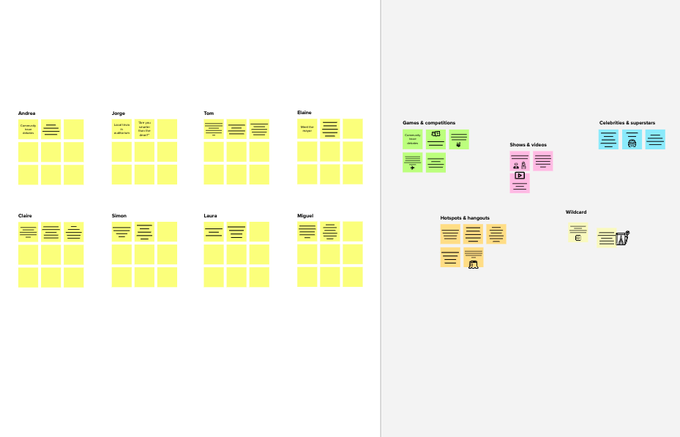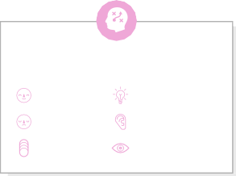

**Template**

**Need some inspiration?**

See a finished version of this template to kickstart your work.

[**Open example**](https://app.mural.co/template/e5a93b7b-49f2-48c9-afd7-a635d860eba6/93f1b98d-b2d2-4695-8e85-7e9c0d2fd9b9)